How to open project file:

**Extracting Project Folder**

1. Copy rar file to a desired location on your computer.

2. Extract rar file to using WinRAR

3. Right click on rar file and choose "Extract Here"

Install WinRAR using link: <https://www.win-rar.com/download.html>

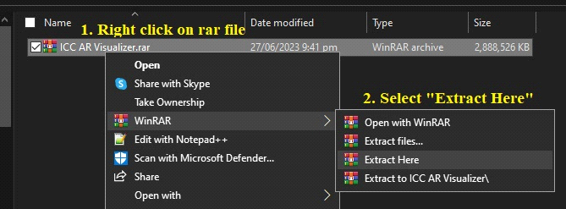

4. Folder will appear once extration is complete.

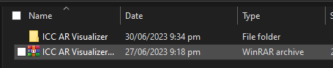

**Downloading and Installing Unity Hub**

Download Unity from link: <https://unity.com/download>

5. Click on the download button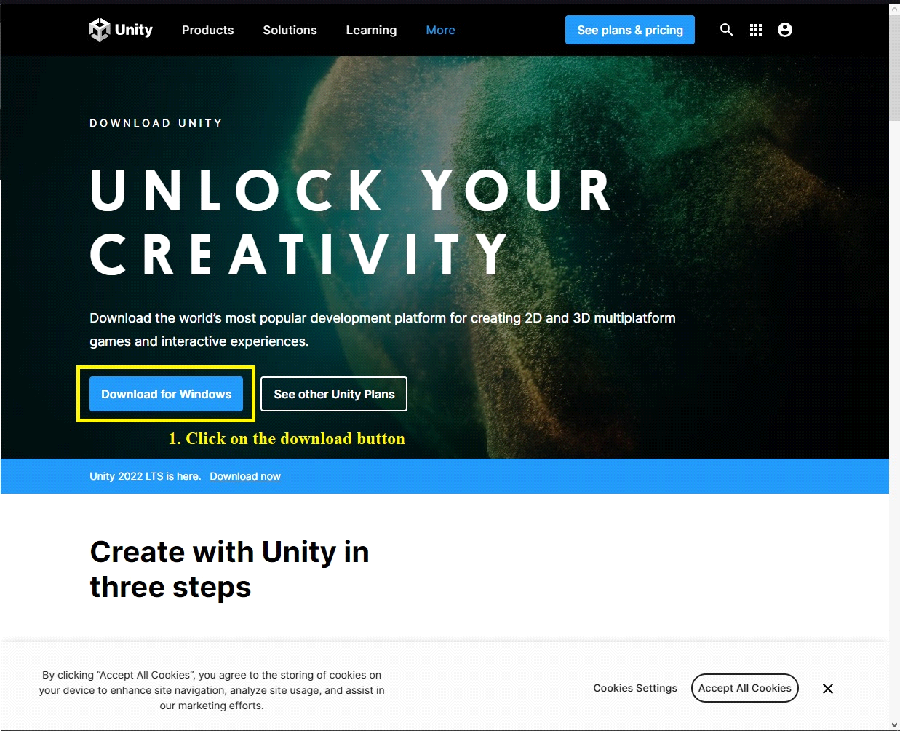

6. If prompted asking where to save the file, Choose where to save the file on your computer and click save

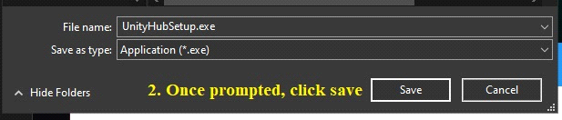

7. Once download is finished, double click on the unity hub installer. If prompted asking for admin control, click "Yes". Continue installing unity hub until succefully installed

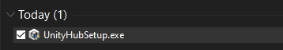

8. Run Unity Hub

9. Click on the drop down option next to the Open button

10. Select the "Add project from disk" in the drop down

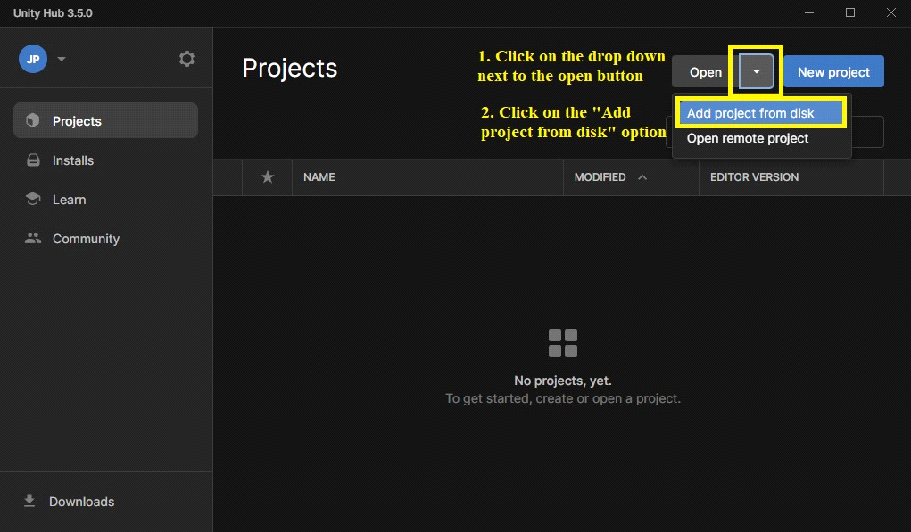

11. Find the project folder that was extracted using WinRAR, and click on the "Add Project" button

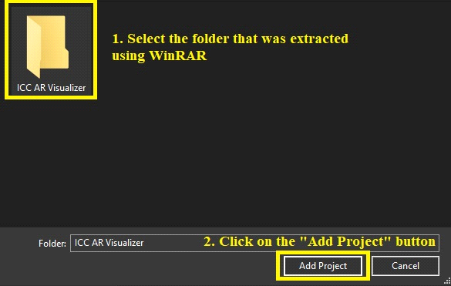

12. Once added, you will be able to see the project folder in unity hub

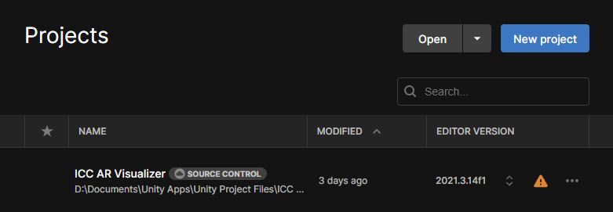

13. Click on the warning sign to install the required unity editor version

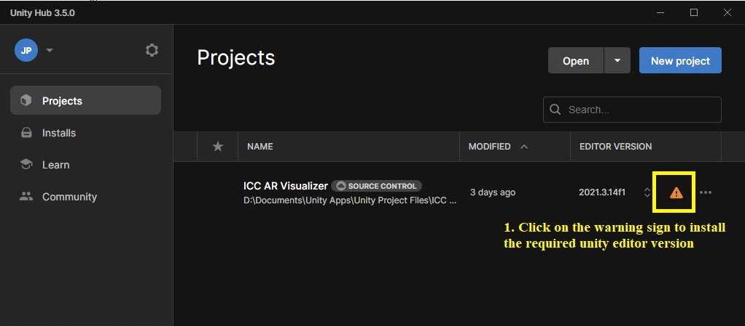

14.Select the missing unity version and click on the Install Version button

NOTE: ICC AR project was created using unity version 2021.3.14f1(LTS)

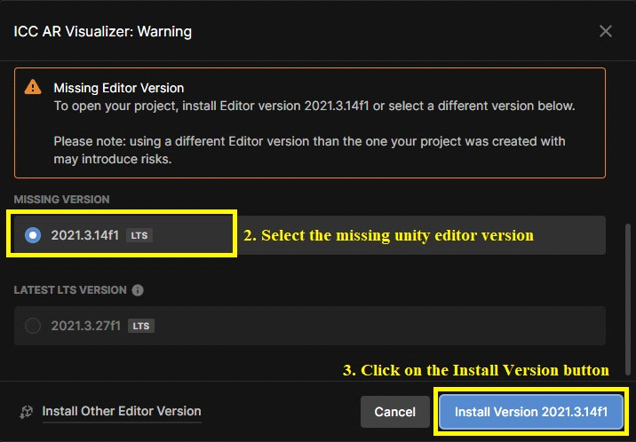

15. Make sure to include all modules related to Android Build Support, this includes "OpenJDK" and "Android SDK & NDK Tools", Click continue when all required modules are selected

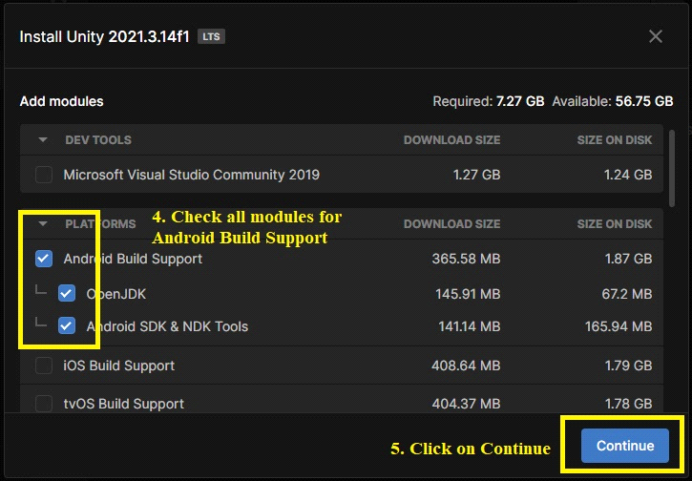

16. Wait for the installation to finish

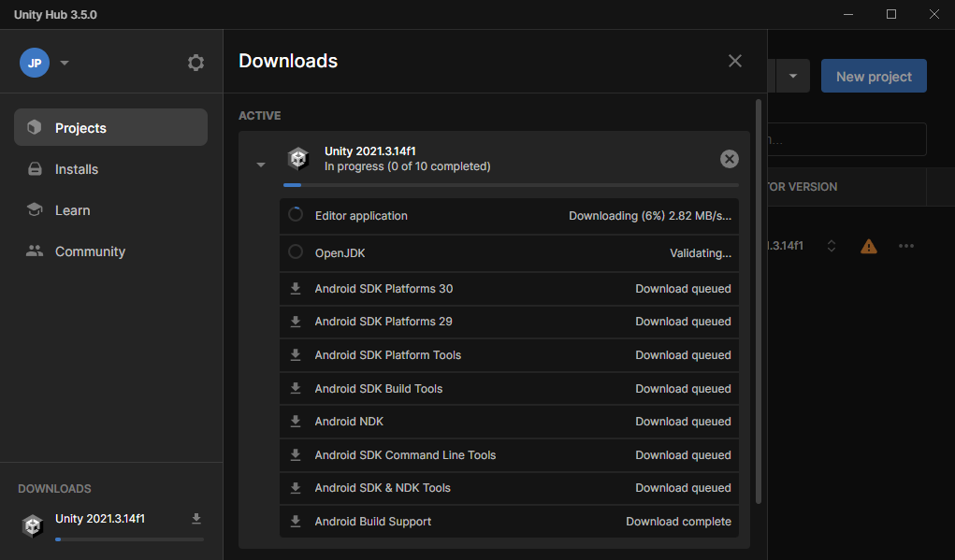

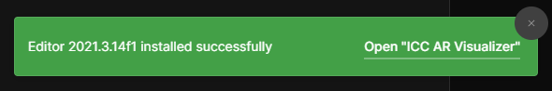

17. Clicking on the project would open the editor where the project can be viewed and edited

